JIM PREPARATORY NURSERY & PRIMARY SCHOOL
IKI-IKI
MOTTO: OUR GOD IS ABLE
TERM TWO ASSEAAMENT EXAMS SET V 2023
PRIMARY SEVEN
INTEGRATED SCIENCE
DURATION: 2HRS 15 MIN
NAME: ..................................................................................
STREAM: ..............................................................................
FOR EXAMINERS’ USE ONLY

FOR EXAMINERS’ USE ONLY
Qn. No. | MARKS | EXR’S NO.
1 – 10
11 – 20
21 – 30
31 – 40
41 – 43
44 - 46
47 - 49
50 - 52
53 - 55
TOTAL
Read the following instructions carefully.
- This paper has two sections: A and B.

- Section A has 40questions (40 marks)

- Section B has 15 questions (60marks)

- Answer all questions. All answers to both sections A and B must be written in spaces provided.

- All answers must be clearly written using blue or black ball point pen or ink.

- Unnecessary changes of work may lead to loss of marks.

- Any handwriting that cannot be easily read, may lead to loss of marks.

- Do not fill anything in the boxes indicated for official use only.

Section A : (40Marks)
1. Mention the process by which nimbus clouds are formed.
………………………………………………………………………………….
2. Write one energy resource from water.
………………………………………………………………………………….
3. Give one way in which some bacteria are useful to people.
………………………………………………………………………………….
4. What name is given to the non metallic conductor of electricity
in a dry cell?
………………………………………………………………………………….
5. Give one way of storing fish at home safe without getting
spoiled.
………………………………………………………………………………….
6. State one cause of soil erosion.
………………………………………………………………………………….
7. How does proper cooking of meat help to protect people from
getting tapeworms?
………………………………………………………………………………….
8. State the importance of the pigment found in plants.
………………………………………………………………………………….
The diagram below shows a banana plant. Use it to answer questions 9 and 10.
X
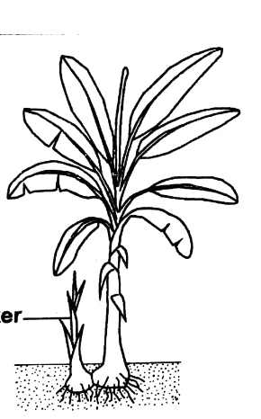
Y
9. Name part marked X.
………………………………………………………………………………….
10. State one advantage part Y has as it grows.
.……………………………………………………………………………….

11. Mention one form of energy produced by a ball when it is
kicked.
.……………………………………………………………………………….
12. Give one way of maintaining the hygiene of utensils at home.
.……………………………………………………………………………….
13. Why is carbondioxide used to preserve drinks?
.……………………………………………………………………………….
14. State one similarity between a sugarcane and irish potato in
the way they store their food.
.……………………………………………………………………………….
15. Give one effect of smoking to the lungs.
.……………………………………………………………………………….
16. Mention one importance of radiation to people.
.……………………………………………………………………………….
17. Write one example of a flat bone.
.……………………………………………………………………………….
18. What immediate advice can you give to a fellow pupil who has
poured hot porridge on her hand?
.……………………………………………………………………………….
The diagram below shows a musical instrument. Use it to answer questions 19 and 20.
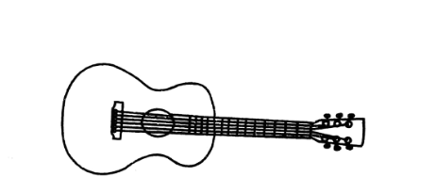
19. Name the musical instrument above.
.……………………………………………………………………………….
20. How is the musical instrument above played?
.……………………………………………………………………………….

21. Give one tool used in the stocking of bee hives.
.……………………………………………………………………………….
22. State one danger of failure to keep latrines clean.
.……………………………………………………………………………….
23. How do most fungi reproduce?
.……………………………………………………………………………….
24. Give one danger of polythene bags on the soil.
.……………………………………………………………………………….
25. How does slashing tall grass around homes help to control
the spread of malaria?
.……………………………………………………………………………….
26. Name the viral disease that causes swelling of glands in the
neck and face.
.……………………………………………………………………………….
The diagram below shows an instrument used to measure weight. Use it to answer questions 27 and 28.
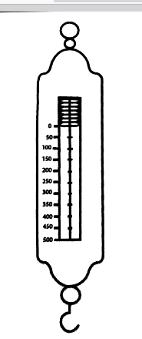
27. Name the instrument in the diagram.
.……………………………………………………………………………….
28. Why does the instrument above give its measurement in
Newtons?
.……………………………………………………………………………….
29. Why is the floor of a pigsty constructed in a slanting way?
.……………………………………………………………………………….
30. Mention one proper storage of garden tools.
.……………………………………………………………………………….

31. Give one factor considered by animals as they choose a place
where to reproduce from.
.……………………………………………………………………………….
32. State one advantage of row planting.
.……………………………………………………………………………….
33. Which part of legumes makes them different from other
dicots?
.……………………………………………………………………………….
34. Mention the quantity of sugar needed to make ORS locally
using one litre of water.
.……………………………………………………………………………….
35. Name one breed of chickens reared by people.
.……………………………………………………………………………….
The diagram below shows a method of grazing goats. Use it to answer questions 36 and 37.
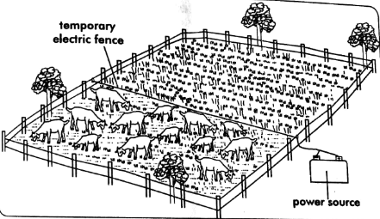
36. Name the method shown above.
.……………………………………………………………………………….
37. State one advantage of using the method shown above.
.……………………………………………………………………………….
38. State one use of magnets to people.
.……………………………………………………………………………….
39. Which practice can be done regularly to strengthen muscles?
.……………………………………………………………………………….
40. Mention the waste product excreted by the skin.
.……………………………………………………………………………….

SECTION B ( 60 MARKS)
41(a) Mention the method of feeding highly recommended for
babies between 0 and 6 months.
.……………………………………………………………………………….
(b) State two advantages of the method mentioned in a) above to
babies.
i)…………..…………………………………………………………………
ii)……………………………………………………...…………………….
(c) Why is proper hygiene important when feeding babies?
.……………………………………………………………………………….
42(a) Mention one class of cold blooded vertebrates.
.……………………………………………………………………………….
(b) How do cold blooded vertebrates reproduce?
……………………………………………..…………..…………………….
(c) Apart from reproduction, mention two other factors used to
group animals together.
i).…………………………………………..…………………………………
ii)……………………………………………………………………………..
43(a) In a statement, write the meaning of essential drugs.
………………………………………………………………………………
(b) State two importance of essential drugs to people.
i)……………………………………………………………….……………
ii) …………………………………………………………………………..
(c) Give one proper storage of essential drugs.
….……………………………………………………………………………

44. The diagram below shows a joint in the human body. Use
it to answer questions that follow.
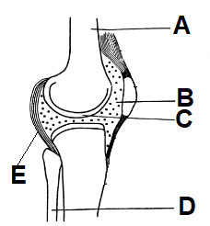
(a) Name parts marked A and D.
i) A………………………………… ii) D…………………………….
(b) State the importance of part marked E.
..………………………………………..…………..…………………….
(c) How is the function of part B similar to that of C?
.……………………………………………………………………………
45(a) Mention the component of soil formed by;
i) weathering ……………………………………….…………………….
ii) rotting ………………………………………………………………….

(b) State two importance of the component formed by rotting in
the soil.
i) ……………………………………………………………………………
ii)……………………………………………….…………..……………….
46(a) State the meaning of harvesting as used in crop husbandry.
…………………………………………….…………………….………….
(b) Mention any two methods used to harvest crops.
i)………………………………………..….………..……………………..
ii)……………………………………………………………………………
(c) Why should harvested crops be dried well before storage?
………………………………………………………………………………

47(a) Give two diary breeds of cattle.
i) ……………………………..…… ii)…...………………………..….
(b) State two ways of making dairy cattle produce more milk.
i)………………………………………..…………..……………………..
ii)………………………………………………………………………….
48. Use the illustration about the number of teeth in human
beings to answer questions that follow.

₄I C P
- upper jaw
- lower jaw
4
4
2
2
4

(a) Identify the set of teeth shown above.
………………………………………………………………………………
(b) Which type of teeth misses in the set of teeth above?
…………………………………………..…………..……………………..
(c) Why is the above set of teeth called a deciduous set?
………………………………………………………………………………
(b) How can teeth be protected from dental carries?
…………………………………………..…………..……………………..
49(a) Mention two chemical changes that produce energy.
i) ……………………………..……. ii)…………………………………
(b) Give one similarity between chemical and biological changes.
…………………………………………..…………..……………………..
(c) State one importance of chemical changes in the
environment.
………………………………………………………………………………

50. The diagram below shows the life cycle of an insect. Use it
to answer questions that follow
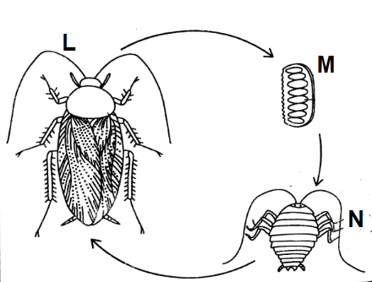
(a) Identify the insect shown in the diagram.
………………………………………………………………………………
(b) Name stage marked N.
………………………………………………………………………………
(c) State two ways of controlling the insect at stage M.
i).……………………………………………………………………………
ii) ……………………………………………………………………………
51(a) Mention two weather instruments that show the direction of
wind.
i).…………………………..……… ii)………….……………..………
(b) Give two uses if wind to people.
i)…………………………………………………………….………………
ii)….…………………………………………………………….………….
52. Match the elements of PHC in list A with activities done to
promote them in list B correctly.

List A List B
Health education Washing hands after using a toilet
Water and sanitation Immunisation with tetanus toxoid
vaccine
Maternal and Removing broken containers from
child health care the compound
Control of Displaying messages on posters
Communicable
diseases

i) Health education ….………………………………………………
……………………………………………………………………………..
ii) Water and sanitation …………………………………………………
……………………………………………………………………………..
iii) Maternal and child health care ……………………………………
…………………………………………………………………………….
iv) Control of communicable diseases………………………………..
…………………………………………………………………………….

53(a) Mention two materials used to produce biogas.
i)..…………………………………… ii)..………………………………
(b) State the role of bacteria in the production of biogas.
....…………………………………………..………………………………
(c) How does the use of biogas help to conserve the
environment?
..…………….………………………………………………………………
54(a) Mention the method used to make water pure.
……………………………………………….………………………………
(b) State two properties of pure water.
i)..……………………………………………………..……………………
ii)..……………………………………………………………………..……
(c) Give one use of pure water to people.
……………………………………………………………………………..
55. Arrange the components of an electric circuit below to
form a complete circuit.

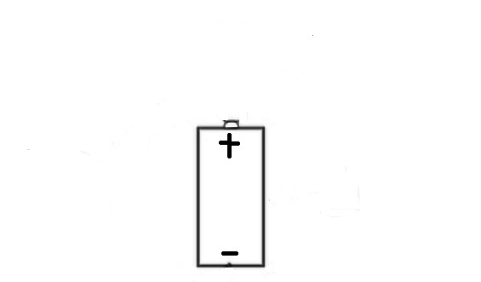

End

